Ansible Installation:

Ansible ICU:  
--------------------  
  
one Master Node And Many Client Nodes:  
  
Installation:  
------------------  
Need to install on master no need to install on all Clients /Slaves  
prerequisites:  
-----------------------  
1) python must already been installation as Ansible is developed in python  
2) in master and all clients python should be installed  
Installation:  
---------------------  
yum install ansible -y  
******** in redhat 7 it worked and but i saw in rhl 8.2 its not working need to   
search about it  
Configuration:(Always fallow official website)::  
--------------------------------------------------------------------------  
the default path of ansible is /etc/ansible/  
configuration file of all defaults settings : /etc/ansible/ansible.cfg  
inventory file : all target servers ip address stored in /etc/ansible/hosts  
  
As a root user the configurations need to set up on Master node is::  
install python   
install ansible  
create a user because its dangerous to execute commands on remote servers as root ,,.it snot recommended

1)useradd ansadmin

2)passwd ansadmin

3)visudo

>>## Same thing without a password

ansadmin ALL=(ALL) NOPASSWD: ALL

4)vim /etc/ssh/sshd_config

# To disable tunneled clear text passwords, change to no here!

PasswordAuthentication yes

5)service sshd restart

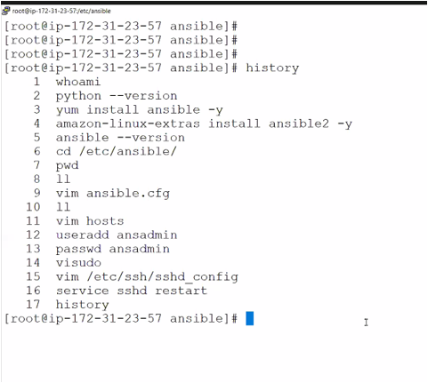

Switch to ansuser

1)Genarate the key

Ssh-keygen

2) change to .ssh path

Cd .ssh

3)send the key to remote server

Ssh-copy-id <public-ip-client>

Make sure open port 22 at the client side

4)add target servers ips in /etc/ansible/hosts file

5) try to connect

$ ansible all -m ping

All🡪 all servers in host file

-m 🡪 as Ansible is a Module based tool we are sending modulesy

Ping -> is one of the module

As ansadmin user things done in master:

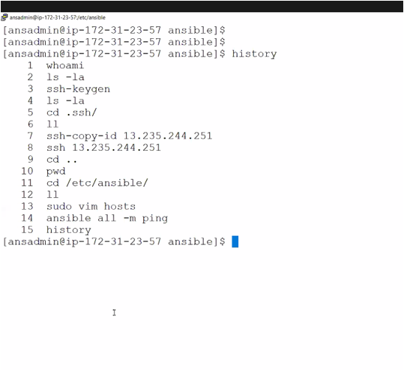

As a root user need todo following on all clients:

make sure to install python

1)useradd ansadmin

2)passwd ansadmin

3)visudo

>>## Same thing without a password

ansadmin ALL=(ALL) NOPASSWD: ALL

4)vim /etc/ssh/sshd_config

# To disable tunneled clear text passwords, change to no here!

PasswordAuthentication yes

5)service sshd restart

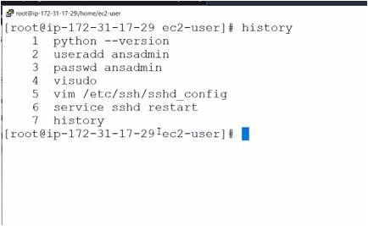

------------------------------------< END OF CONFIGURATION>-----------------------------------------------

HOW TO USE:

Ansible all -m ping

Ansible 192.168.56.100:192.168.56.101 -m ping

: is saparation, we can ping many servers at one time as Ansible will fallow Parallel Execution and push based method so no need to install any agents in all clients ,,.just need to open port 22 is enough .

Its difficult add 100 servers if exist ..,so grouping the servers in /etc/ansible/hosts file

[dev]

192.168.56.100

192.168.56.102

192.168.56.103

[pre-prod]

192.168.56.108

192.168.56.109……………………….etc

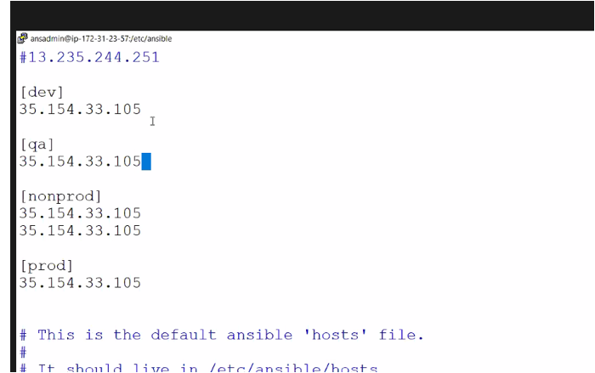

--🡪 I can also copy the default path of the ansible to users home location we can change default setting as well ..

1)create a directory

Mkdir myproj

Go to that dir

Cd myproj

cp -rpP /etc/ansible/* .

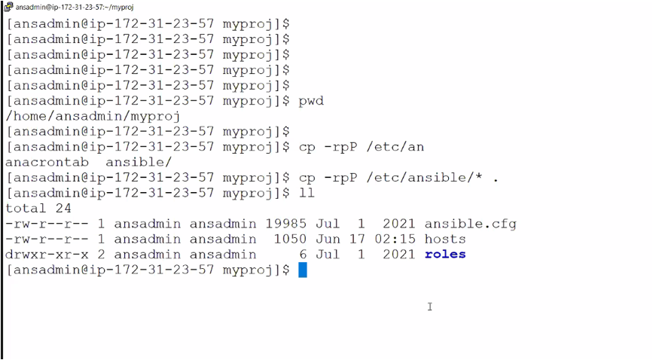

We can change the default settings

